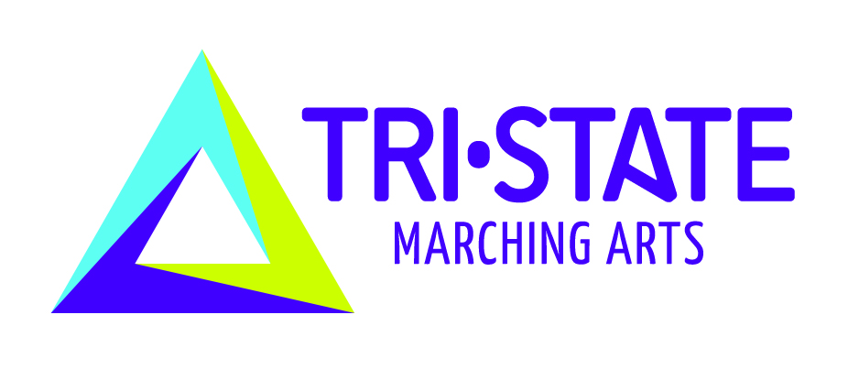

Advisory Committee Meeting May 31st @ 1:30p
Spring General Meeting – Immediately following Advisory Committee Meeting

Proposals for policy and rule changes must be submitted to the TMA office no later 11:59pm on May 9th Proposals must be emailed by that date or it will not be given consideration. Please fill out the proposal form below and email to tristate@tristatemarchingarts.org
Proposal:

Submitted by (proposals with no name will not be considered):

Unit and/or Position (REQUIRED):
Rationale:

Financial Impact:

